Purpose:

The purpose of this lab is for the PCs to ping across 4 routers, and to implement OSPF in the routers. We need the Pcs to ping each other because that shows that they can talk to each other and is what we need the Pcs to do.

Background:

OSPF stands for Open Shortest Path First, and we use it because it helps the routers calculate the best route for traffic to flow in. We are using IP routes for the routers to know where to push all the traffic to when the PCs try to communicate with each other. We used serial ports to connect all the routers to each other, and a straight-through cable to connect each PC to its router. We have to set up the PCs and routers with IPv4 addresses so the PCs have a “name” to ping and communicate with once the time comes.

Lab Summary:

In this lab, we are trying to make the PCs be able to ping each other so we use the IP route command from one router to the PC network. We also need to use the router OSPF command to implement it into the routers.

Lab Commands:

1. Interface
2. This helps us get into the interface of the thing to set IP addresses
3. No shutdown
4. This turns on the specific interface
5. Ip address
6. This sets the IPv4 address of choice
7. Ip route
8. This command implements IP route to the chosen network and interface
9. Router ospf 1
10. This implements OSPF in the routers

Network Diagram with IP’s: 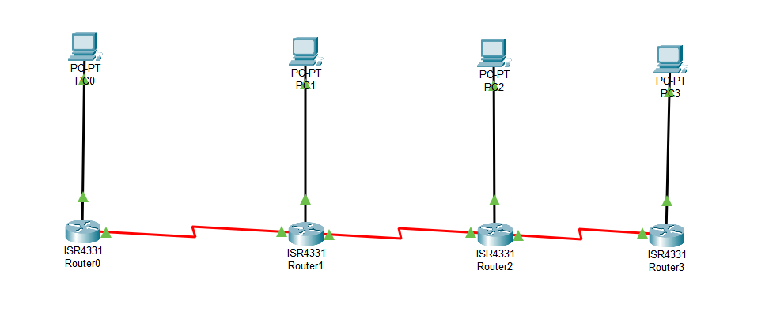



Configurations:

Show Run on router 0:

interface GigabitEthernet0/0/0

ip address 192.168.1.1 255.255.255.0

duplex auto

speed auto

interface GigabitEthernet0/0/1

no ip address

duplex auto

speed auto

shutdown

interface GigabitEthernet0/0/2

no ip address

duplex auto

speed auto

shutdown

interface Serial0/1/0

ip address 192.168.5.1 255.255.255.0

interface Serial0/1/1

no ip address

clock rate 2000000

shutdown

interface Vlan1

no ip address

shutdown

router ospf 1

log-adjacency-changes

network 192.168.1.0 0.0.0.255 area 0

ip classless

ip route 192.168.2.0 255.255.255.0 192.168.5.2

ip route 192.168.3.0 255.255.255.0 192.168.5.2

ip route 192.168.4.0 255.255.255.0 192.168.5.2

ip route 0.0.0.0 0.0.0.0 Serial0/1/0

Show IP Route on Router 0:

Gateway of last resort is 0.0.0.0 to network 0.0.0.0

192.168.1.0/24 is variably subnetted, 2 subnets, 2 masks

C 192.168.1.0/24 is directly connected, GigabitEthernet0/0/0

L 192.168.1.1/32 is directly connected, GigabitEthernet0/0/0

S 192.168.2.0/24 [1/0] via 192.168.5.2

S 192.168.3.0/24 [1/0] via 192.168.5.2

S 192.168.4.0/24 [1/0] via 192.168.5.2

192.168.5.0/24 is variably subnetted, 2 subnets, 2 masks

C 192.168.5.0/24 is directly connected, Serial0/1/0

L 192.168.5.1/32 is directly connected, Serial0/1/0

S\* 0.0.0.0/0 is directly connected, Serial0/1/0

Problems:

A problem I had was not setting the PCs with different networks. I had all the PCs at first at 192.168.1.0/24. But I set each connection with a different network

Another problem I had was having the wrong IP address for the next hop IP address while doing the IP route command. But after some trial and error, I figured it out

Another problem I had at first was figuring out how to put in a serial port into the router, but with the help of others, I figured it out.

Conclusion:

In conclusion, I was able to ping every PC from PC and every router from PC, and I was able to implement OSPF into the routers.